1. Connect Battery to Breadboard
2. Connect Arduino to Breadboard (should have LED on)
3. Plug in USB to computer and connect to Arduino
4. Upload Bluetooth Script to Arduino Thru USB
5. Once uploaded, disconnect USB from Arduino so it is just battery powered
6. Load up Bluetooth LE Explorer (a BLE scanner) on a different computer from the one initially used to upload the script to the Arduino
7. Press ‘Start’ on the initial screen labeled Discover
8. Filter for Nano33_BLE
9. Click on the blue box (don’t click pair just click the middle of the box to load up the details)
10. 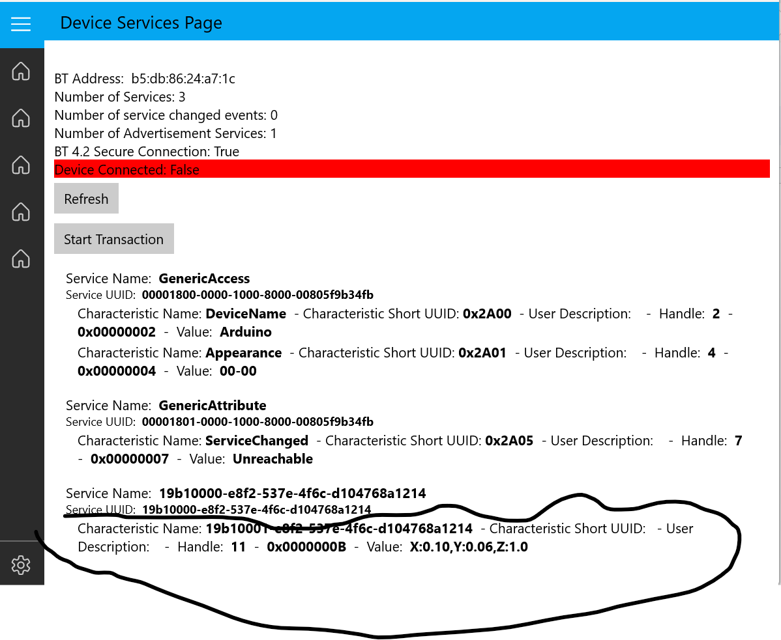

Click on this ^ very bottom section in the details

1. 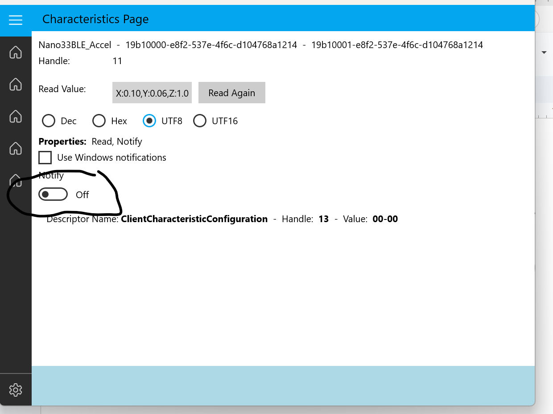

Turn this notify button ON and now you should see the read value towards the top of the page live stream the x, y, and z acceleration